 

**JSPM’s**

**Bhivarabai Sawant Institute of Technology & Research, Pune.**

***Department of Computer Engineering***

***Academic Year 2020-21***

**Mini Project Report on**

**Data Analytics using R.**

Submitted by

***A. Shiva Surya Saran***

Under the guidance of

***Prof. G. R. Virkar***

**Laboratory Practice – I**

***Department of Computer Engineering***

**JSPM’s Bhivarabai Sawant Institute of Technology & Research, Pune.**

***CERTIFICATE***

This is to certify that **A. Shiva Surya Saran** with Roll No. **BE B – 20** submitted his Project report under my guidance and supervision. The work has been done to my satisfaction during the academic year 2020-2021 under Savitribai Phule Pune University guidelines.

**Date:** *9th November, 2020.*

**Place:** *Pune.*

Prof. Gauri Virkar Dr. G. M. Bhandari

**Mini-project Guide HOD**

***Acknowledgement***

This is a great pleasure & immense satisfaction to express my deepest sense of gratitude & thanks to everyone who has directly or indirectly helped me in completing my Project work successfully.

I express my gratitude towards guide Prof. and Dr.G.M. Bhandari Head of Department of Computer Engineering, Bhivarabai Sawant Institute Of Technology and Research, Wagholi, Pune who guided & encouraged me in completing the Project work in scheduled time. I would like to thank our Principal, for allowing us to pursue my Project in this institute.

  **A. Shiva Surya Saran**

**(BE B - 20)**

***Aim & Objective***

*Download Breast Cancer Wisconsin (Diagnostic) dataset. Using atleast 2 classification algorithm,*

* Load the data from CSV file and split it into training and test datasets.
* Summarize the properties in the training dataset so that we can calculate probabilities and make predictions.
* *Classify samples from a test dataset and a summarized training dataset.*
* *Compare the Confusion Matrix of the respective classification algorithms and find out which is the best algorithm.*

***System Requirements***

**Hardware**

* Quad-core 64-bit i7 Intel Processor
* 8 GB RAM
* 16 GB storage

**Software**

* Ubuntu 20.04 Operating System
* R Studio

***Code & Output***

Dataset Link - https://archive.ics.uci.edu/ml/datasets/Breast+Cancer+Wisconsin+%28Diagnostic%29

#Brief Overview of the Data set

Predicting Results

- predicting field 2, diagnosis: B = benign, M = malignant

- sets are linearly separable using all 30 input features

- best predictive accuracy obtained using one separating plane in the 3-D space of Worst Area, Worst Smoothness and Mean Texture. Estimated accuracy 97.5% using repeated 10-fold crossvalidations. Classifier has correctly diagnosed 176 consecutive new patients as of November 1995.

Ten real-valued features are computed for each cell nucleus:

a) radius (mean of distances from center to points on the perimeter)

b) texture (standard deviation of gray-scale values)

c) perimeter

d) area

e) smoothness (local variation in radius lengths)

f) compactness (perimeter^2 / area - 1.0)

g) concavity (severity of concave portions of the contour)

h) concave points (number of concave portions of the contour)

i) symmetry

j) fractal dimension ("coastline approximation" - 1)

Several of the papers listed above contain detailed descriptions of

how these features are computed.

The mean, standard error, and "worst" or largest (mean of the three

largest values) of these features were computed for each image,

resulting in 30 features. For instance, field 3 is Mean Radius, field

13 is Radius SE, field 23 is Worst Radius.

All feature values are re-coded with four significant digits.

Class distribution: 357 benign, 212 malignant

> #Installing the libaries

>

> install.packages('e1071')

> install.packages('caTools')

>

>

> #Checking that the libraries are successfully installed

> library(caTools)

> library(e1071)

>

> #Importing The Dataset

> mydata <- read.csv("/home/shiva/Documents/BE/LP1/Cancer_Dataset/data.csv")

>

> #Checking the Dataset

> View(mydata)

>

> #Dimensions of the DataSet

> dim(mydata)

[1] 569 33

> names(mydata)

[1] "id" "diagnosis" "radius_mean" "texture_mean" "perimeter_mean"

[6] "area_mean" "smoothness_mean" "compactness_mean" "concavity_mean" "concave.points_mean"

[11] "symmetry_mean" "fractal_dimension_mean" "radius_se" "texture_se" "perimeter_se"

[16] "area_se" "smoothness_se" "compactness_se" "concavity_se" "concave.points_se"

[21] "symmetry_se" "fractal_dimension_se" "radius_worst" "texture_worst" "perimeter_worst"

[26] "area_worst" "smoothness_worst" "compactness_worst" "concavity_worst" "concave.points_worst"

[31] "symmetry_worst" "fractal_dimension_worst" "X"

>

>

> #internal structure

> names(mydata)

[1] "id" "diagnosis" "radius_mean" "texture_mean" "perimeter_mean"

[6] "area_mean" "smoothness_mean" "compactness_mean" "concavity_mean" "concave.points_mean"

[11] "symmetry_mean" "fractal_dimension_mean" "radius_se" "texture_se" "perimeter_se"

[16] "area_se" "smoothness_se" "compactness_se" "concavity_se" "concave.points_se"

[21] "symmetry_se" "fractal_dimension_se" "radius_worst" "texture_worst" "perimeter_worst"

[26] "area_worst" "smoothness_worst" "compactness_worst" "concavity_worst" "concave.points_worst"

[31] "symmetry_worst" "fractal_dimension_worst" "X"

> #Statistics of Major attributes useful for predicting the diagonsis.

> #Min Values

> min(mydata$area_worst)

[1] 185.2

> min(mydata$smoothness_worst)

[1] 0.07117

> min(mydata$texture_mean)

[1] 9.71

>

>

> #Max Values

> max(mydata$area_worst)

[1] 4254

> max(mydata$smoothness_worst)

[1] 0.2226

> max(mydata$texture_mean)

[1] 39.28

>

>

> #Range

> range(mydata$area_worst)

[1] 185.2 4254.0

> range(mydata$smoothness_worst)

[1] 0.07117 0.22260

> range(mydata$texture_mean)

[1] 9.71 39.28

>

>

> #Standard Deviation

> sd(mydata$area_worst)

[1] 569.357

> sd(mydata$smoothness_worst)

[1] 0.02283243

> sd(mydata$texture_mean)

[1] 4.301036

>

>

> #Variance

> var(mydata$area_worst)

[1] 324167.4

> var(mydata$smoothness_worst)

[1] 0.0005213198

> var(mydata$texture_mean)

[1] 18.49891

>

>

> #Percentile

> quantile(mydata$area_worst)

0% 25% 50% 75% 100%

185.2 515.3 686.5 1084.0 4254.0

> quantile(mydata$smoothness_worst)

0% 25% 50% 75% 100%

0.07117 0.11660 0.13130 0.14600 0.22260

> quantile(mydata$texture_mean)

0% 25% 50% 75% 100%

9.71 16.17 18.84 21.80 39.28

> #Data Visualisation

> plot(mydata$area_worst, main = "Diagonsis using Worst Area of Nuceli", ylab = "Worst Area", col=mydata$diagnosis, xlim = c(1,200))

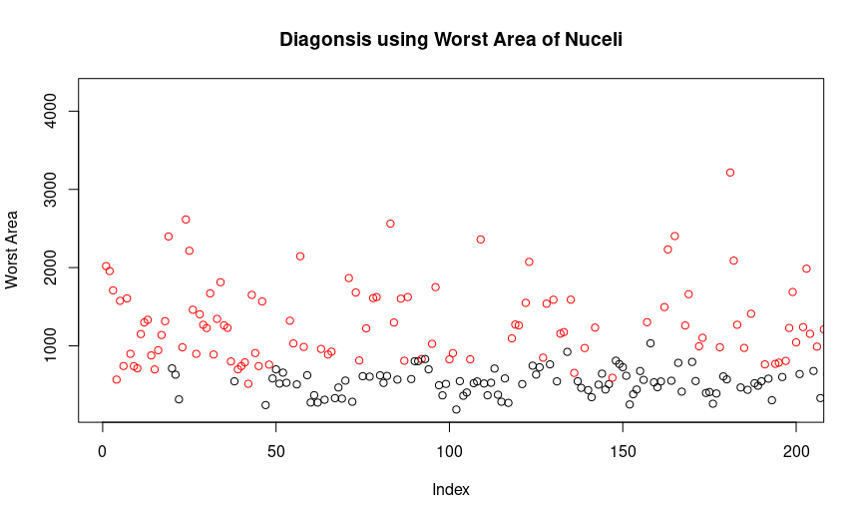

> #Using Worst Smoothness

> plot(mydata$smoothness_worst, main = "Diagonsis using Worst Smoothness of Nuceli", ylab = "Worst Smoothness", col=mydata$diagnosis, xlim = c(1,200))

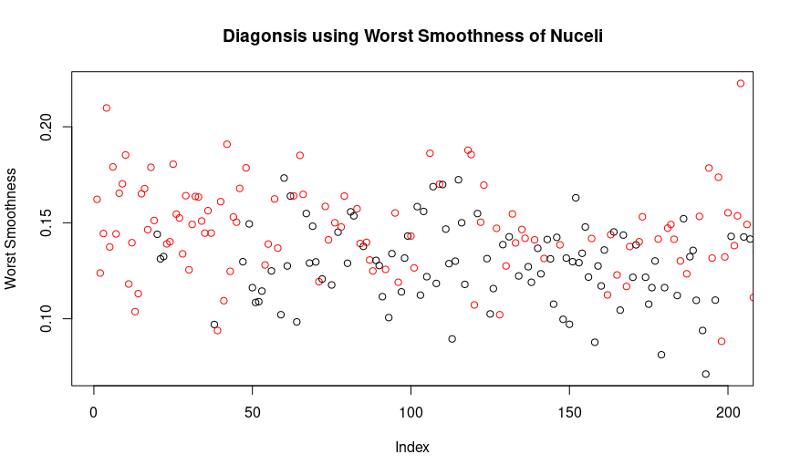

> #Using Mean Texture

> plot(mydata$texture_mean, main = "Diagonsis using Mean Texture of Nuceli", ylab = "Mean Texture", col=mydata$diagnosis, xlim = c(1,200))

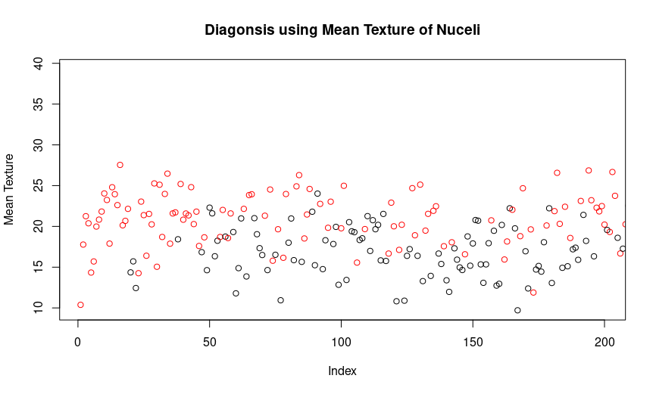

> #Boxplot for Diagnosis using Worst Area

> boxplot(c(mydata$diagnosis), mydata$area_worst)

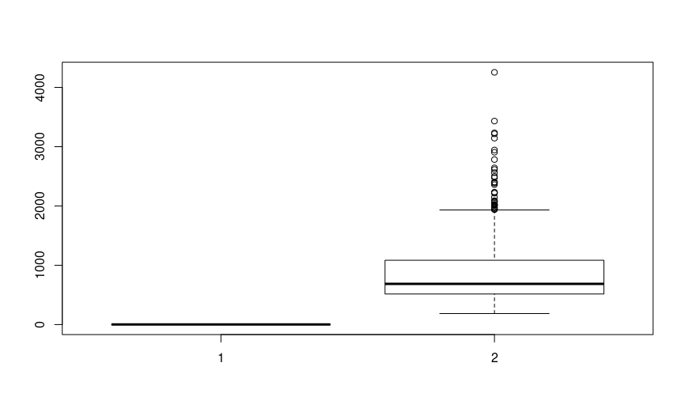

> #Using Classification Algorithm to Predict Diagonsis

> #Splitting the Data into Training and Testing Dataset

> temp_field<-sample.split(mydata$diagnosis,SplitRatio=0.6)

> train<-subset(mydata, temp_field==TRUE)

> test<-subset(mydata, temp_field == FALSE)

>

>

> #Using Naive Bayes Algorithm

> my_model<-naiveBayes(as.factor(train$diagnosis)~.,train)

> pred1<-predict(my_model,test[,-2])

> #Creating Confusion Matrix

> ConFusNavB <- table(pred1, test$diagnosis, dnn=c("predicted", "Actual"))

> ConFusNavB

Actual

predicted B M

B 142 10

M 1 75

#Combining the Test Data and Predicted Data

output<-cbind(test, pred1)

View(output)

> #Using SVM Algorithm

> split = sample.split(mydata$diagnosis, SplitRatio = 0.60)

> training_set = subset(mydata, split == TRUE)

> test_set = subset(mydata, split == FALSE)

> classifier = svm(formula = diagnosis ~ .,data = training_set,type = 'C-classification',kernel = 'linear')

> y_pred = predict(classifier, newdata = test_set[-2])

> ConFusSVM = table(test_set[, 2], y_pred, dnn=c("predicted", "Actual"))

> ConFusSVM

Actual

predicted B M

B 140 3

M 2 83

> #Comparing Confusion Matrices

> #Naives Bayes

> #Correct predicitions Using Naive Bayes

> ConFusNavB[1]+ConFusNavB[4]

[1] 217

>

> #Incorrect predicitions Using Naive Bayes

> ConFusNavB[2]+ConFusNavB[3]

[1] 11

>

> #Correct predicitions % Using Naive Bayes

> CPNB = ((ConFusNavB[1]+ConFusNavB[4])/(ConFusNavB[1]+ConFusNavB[2]+ConFusNavB[3]+ConFusNavB[4]))*100

> CPNB

[1] 95.17544

>

> #Incorrect predicitions % Using Naive Bayes

> IPNB = ((ConFusNavB[2]+ConFusNavB[3])/(ConFusNavB[1]+ConFusNavB[2]+ConFusNavB[3]+ConFusNavB[4]))*100

> IPNB

[1] 4.824561

>

> #SVM

> #Correct predicitions Using SVM

> ConFusSVM[1]+ConFusSVM[4]

[1] 223

>

> #Incorrect predicitions Using SVM

> ConFusSVM[2]+ConFusSVM[3]

[1] 5

>

> #Correct predicitions % Using SVM

> CPSVM = ((ConFusSVM[1]+ConFusSVM[4])/(ConFusSVM[1]+ConFusSVM[2]+ConFusSVM[3]+ConFusSVM[4]))*100

> CPSVM

[1] 97.80702

>

> #Incorrect predicitions % Using SVM

> IPSVM = ((ConFusSVM[2]+ConFusSVM[3])/(ConFusSVM[1]+ConFusSVM[2]+ConFusSVM[3]+ConFusSVM[4]))*100

> IPSVM

[1] 2.192982

***Conclusion***

This project took me through the various concepts of Data Analytics using R and gave a brief outlook of handling large datasets. Also, got learnt about the built-in algorithms like Naïve Bayes to predict outcome of the test data.